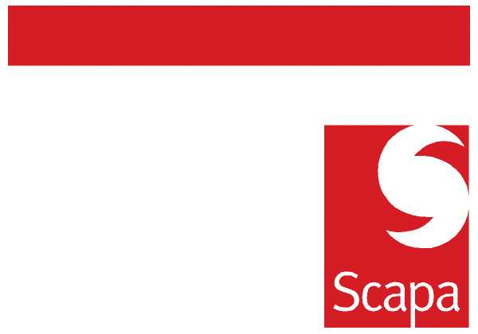

ANNOUNCEMENT

Julie Hulme has resigned from her position as Group HR Director. Julie is leaving to pursue other professional interests and we wish her well for the future.

Over the coming weeks Julie will focus on ensuring that transitional plans are implemented to support the business. We are now working actively to ensure the continuation of the excellent work started by Julie on appraisals and training and development, as well as baseline HR processes. Please continue to support Julie fully in her transitional activities.

Brian Tenner
Group Finance Director

23 March 2010

